**Appendix XIV: Fianl Product Evaluation Question and Particpant Feedback**

**Final Evaluation questions**

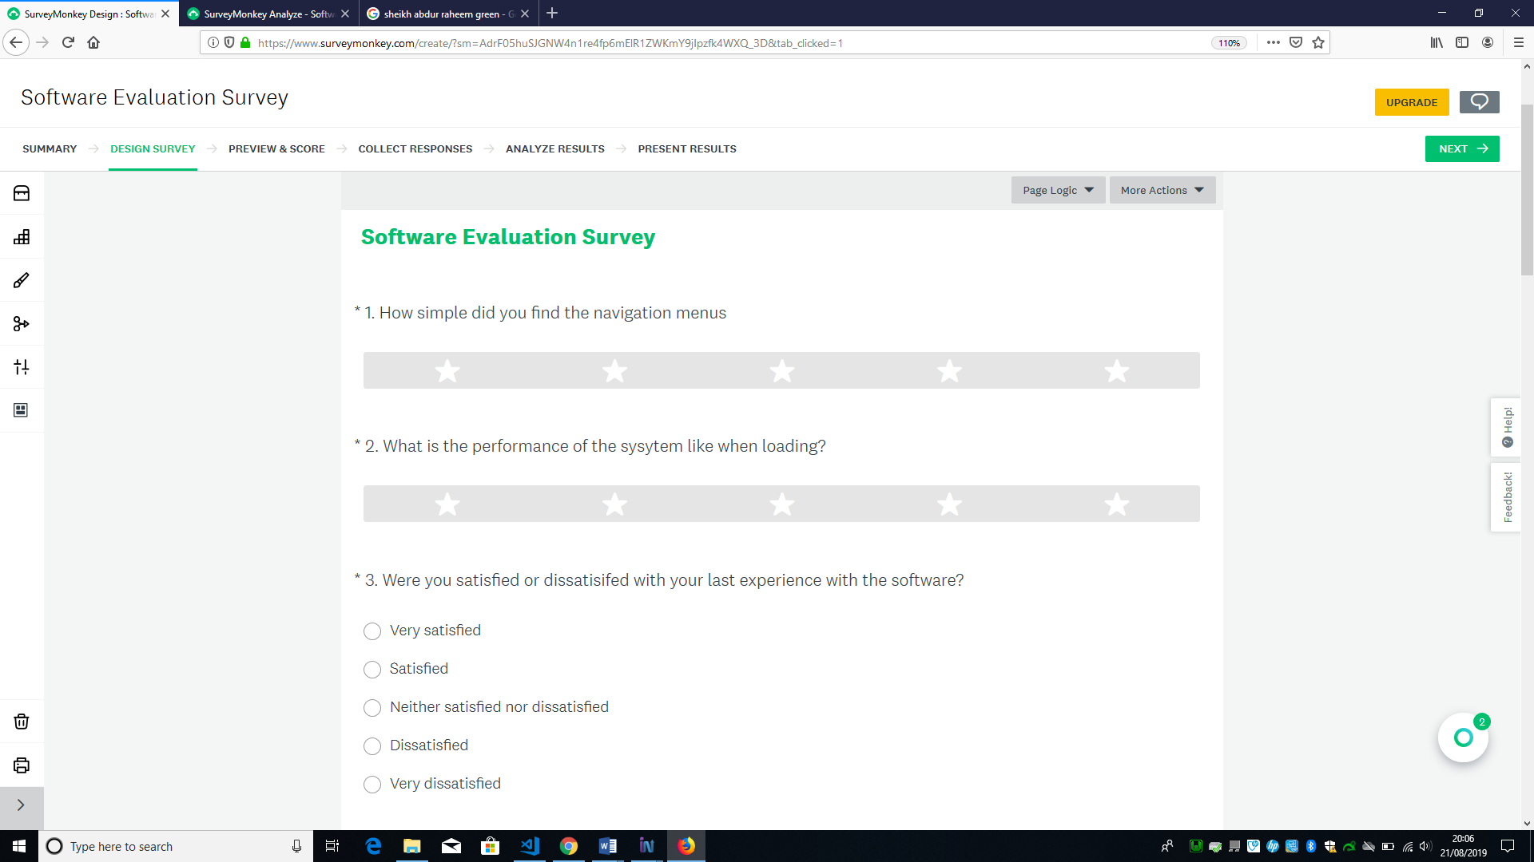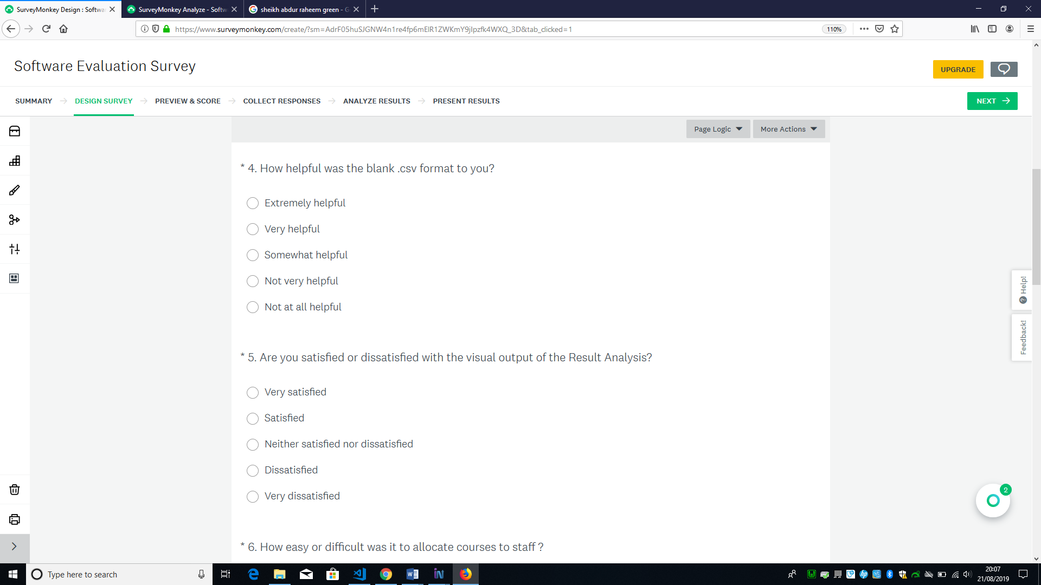 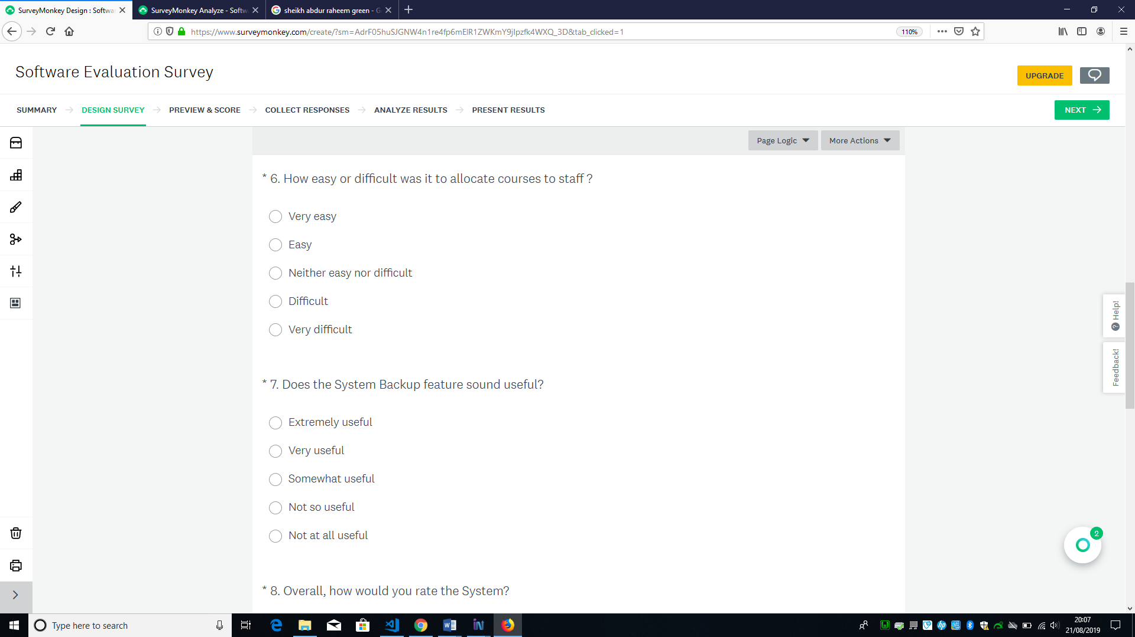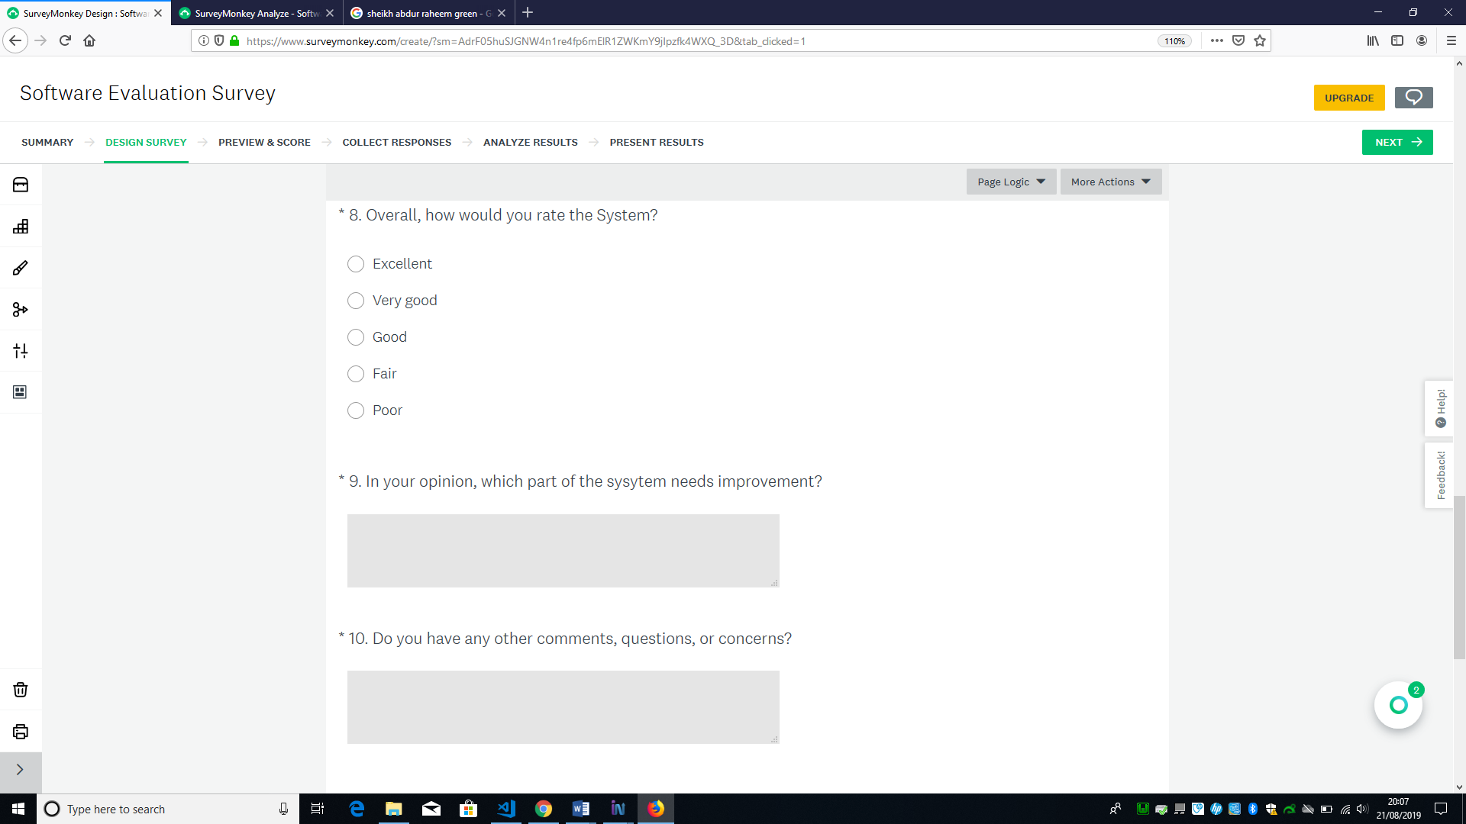

**Participants Feedbacks**

Q1. How simple did you find the navigation menus

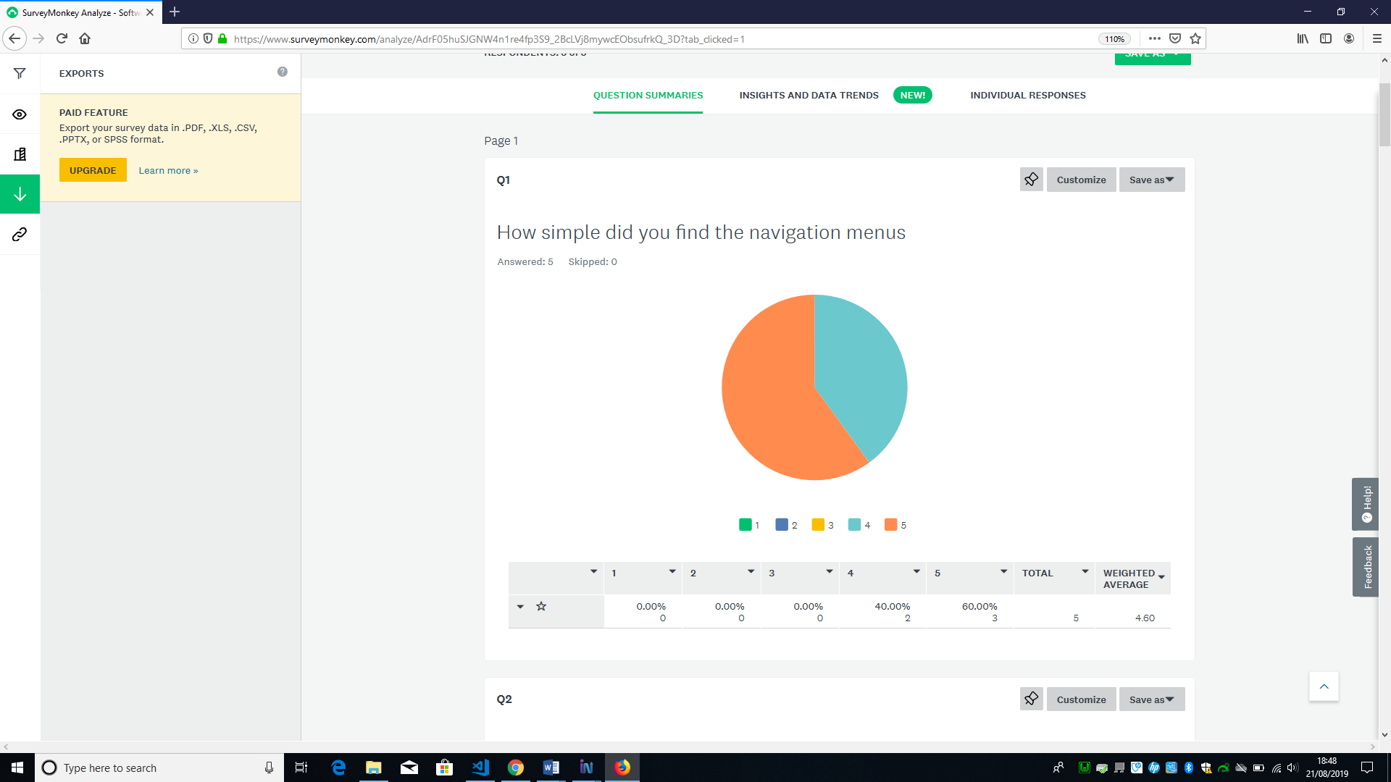

Q2. What is the performance of the system like when loading?

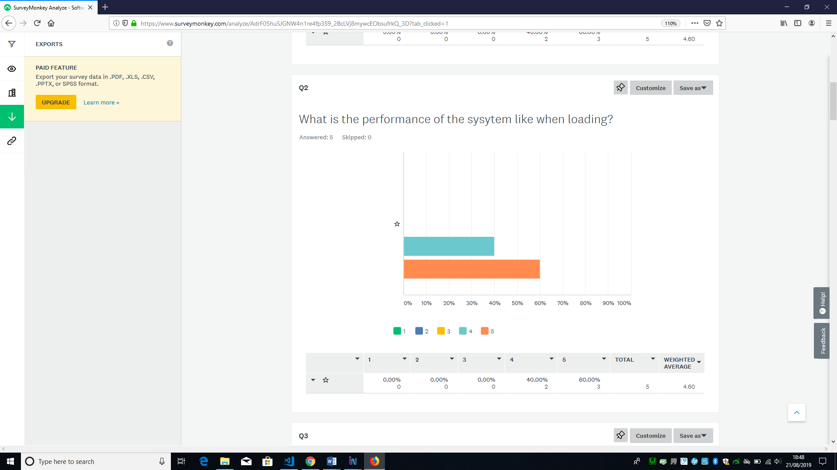

Q4. Were satisfied or dissatisfied with your last experience with the software? 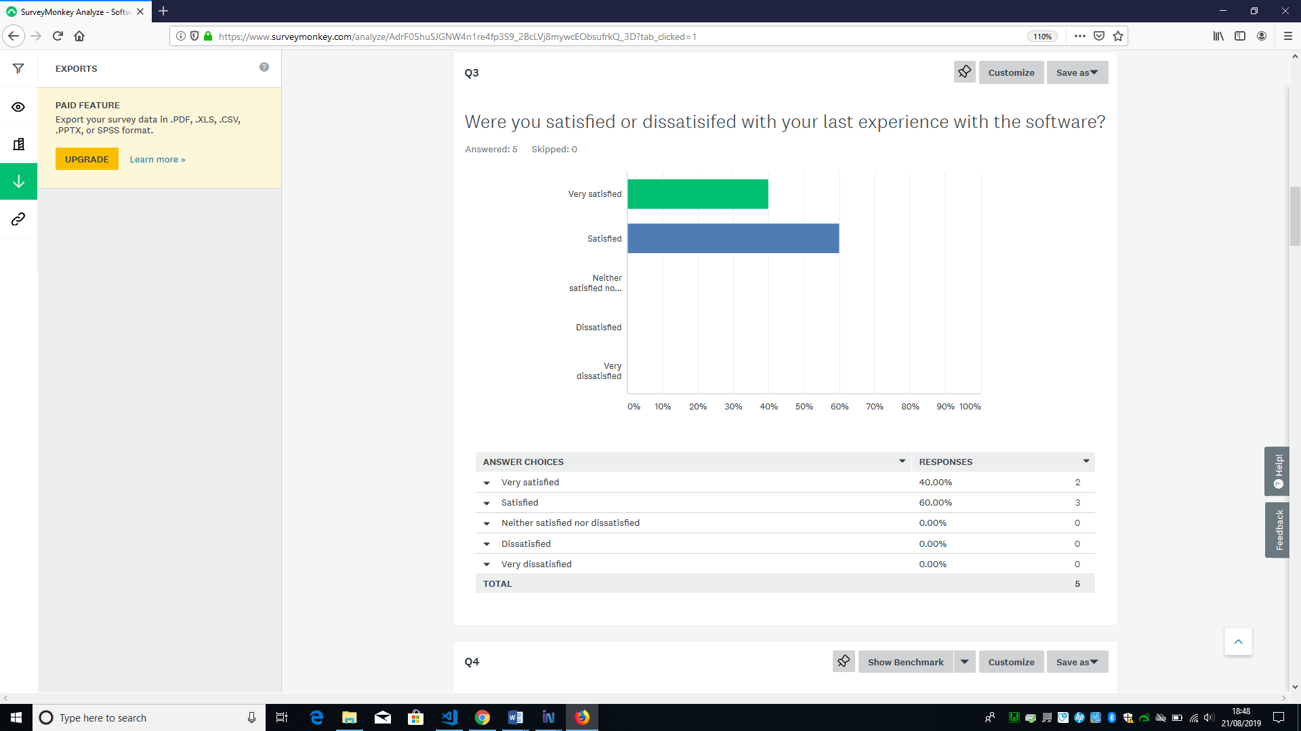

Q4. How helpful was the blank .csv format to you?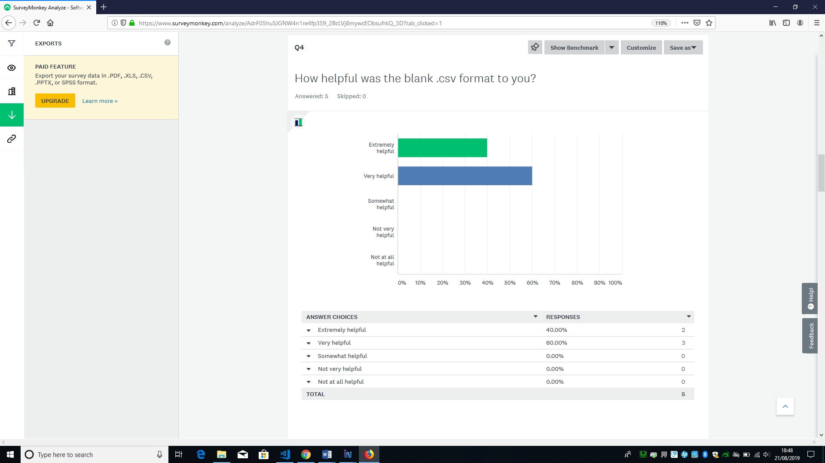

Q5. Are you satisfied with the visual output of the Result Analysis?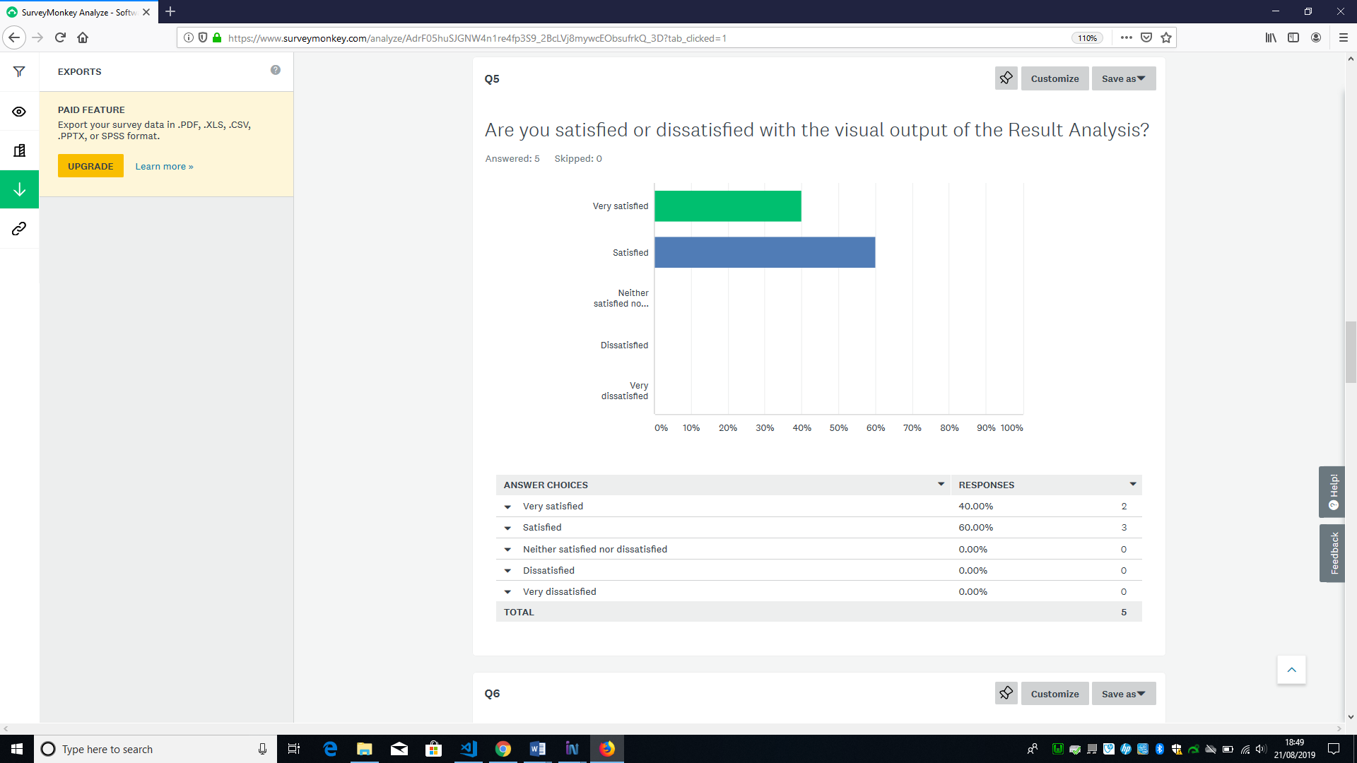

Q6. How easy or difficult was it to allocate courses to staff?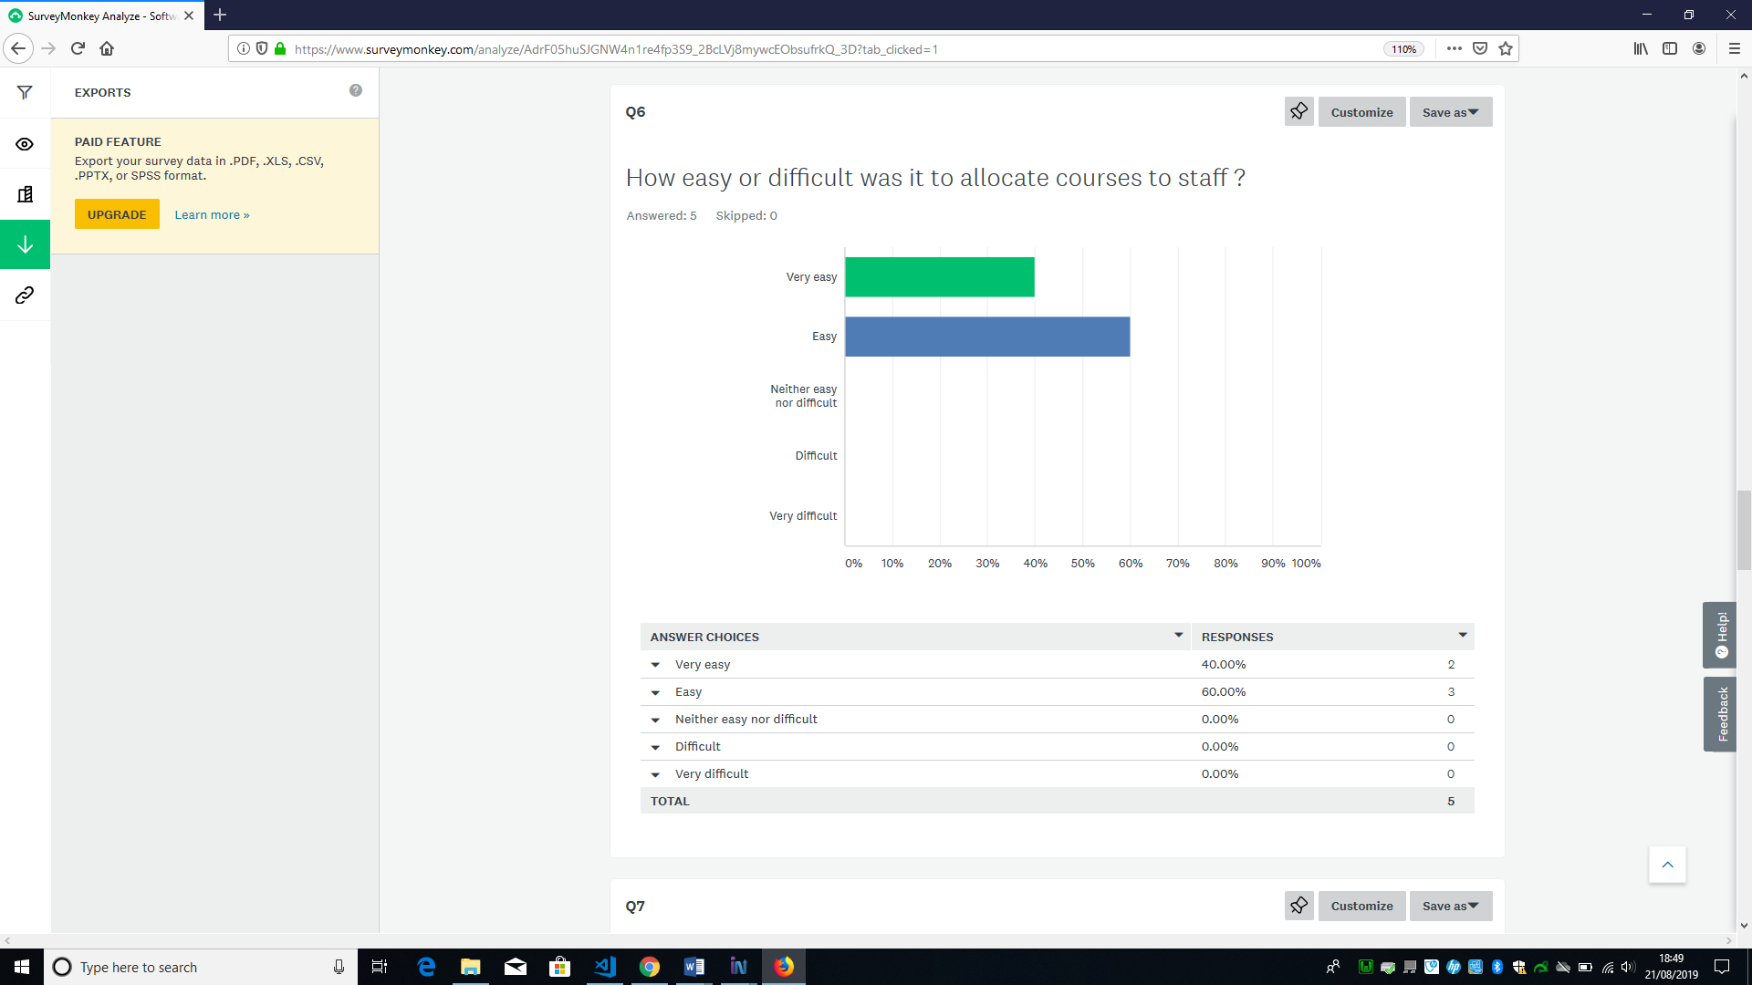

Q7. Does the System Backup feature sound useful?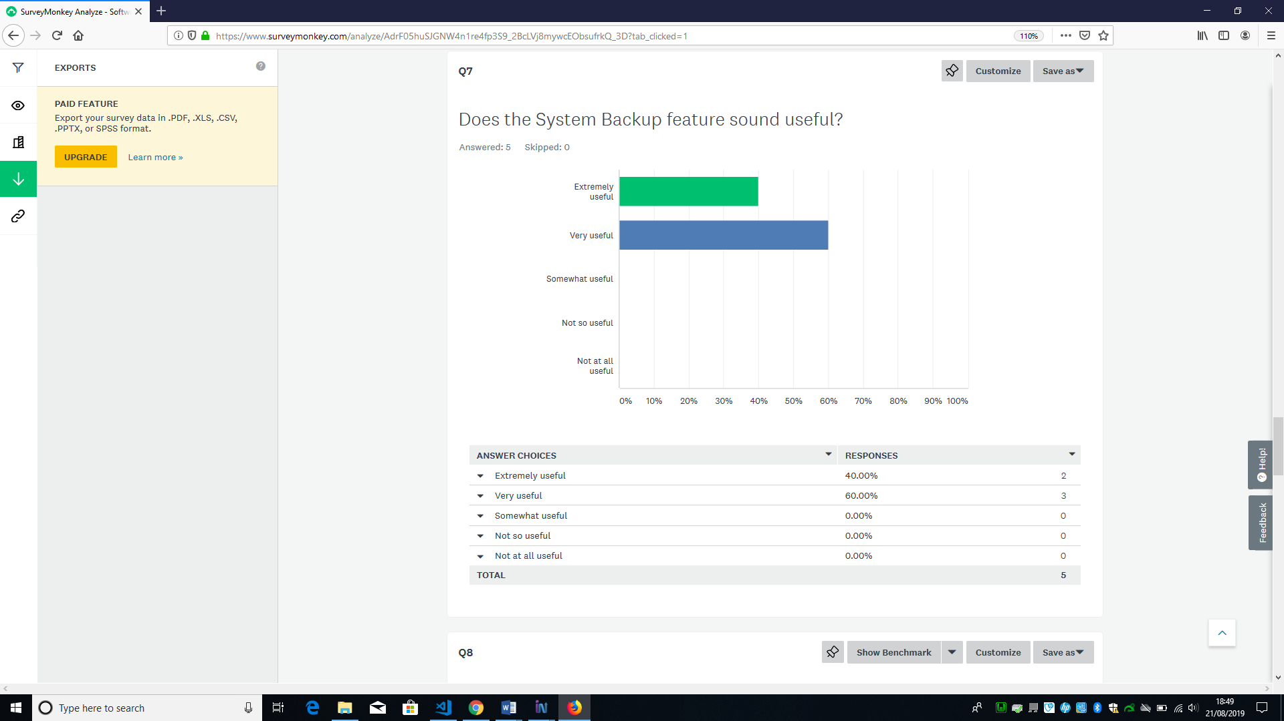

Q8. Overall, how would you rate the System?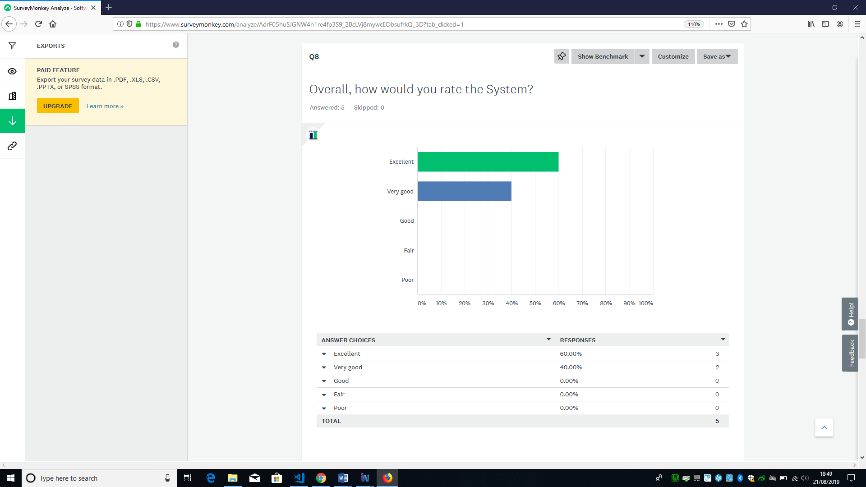

Q9. In your opinion, which part of the system needs improvement? 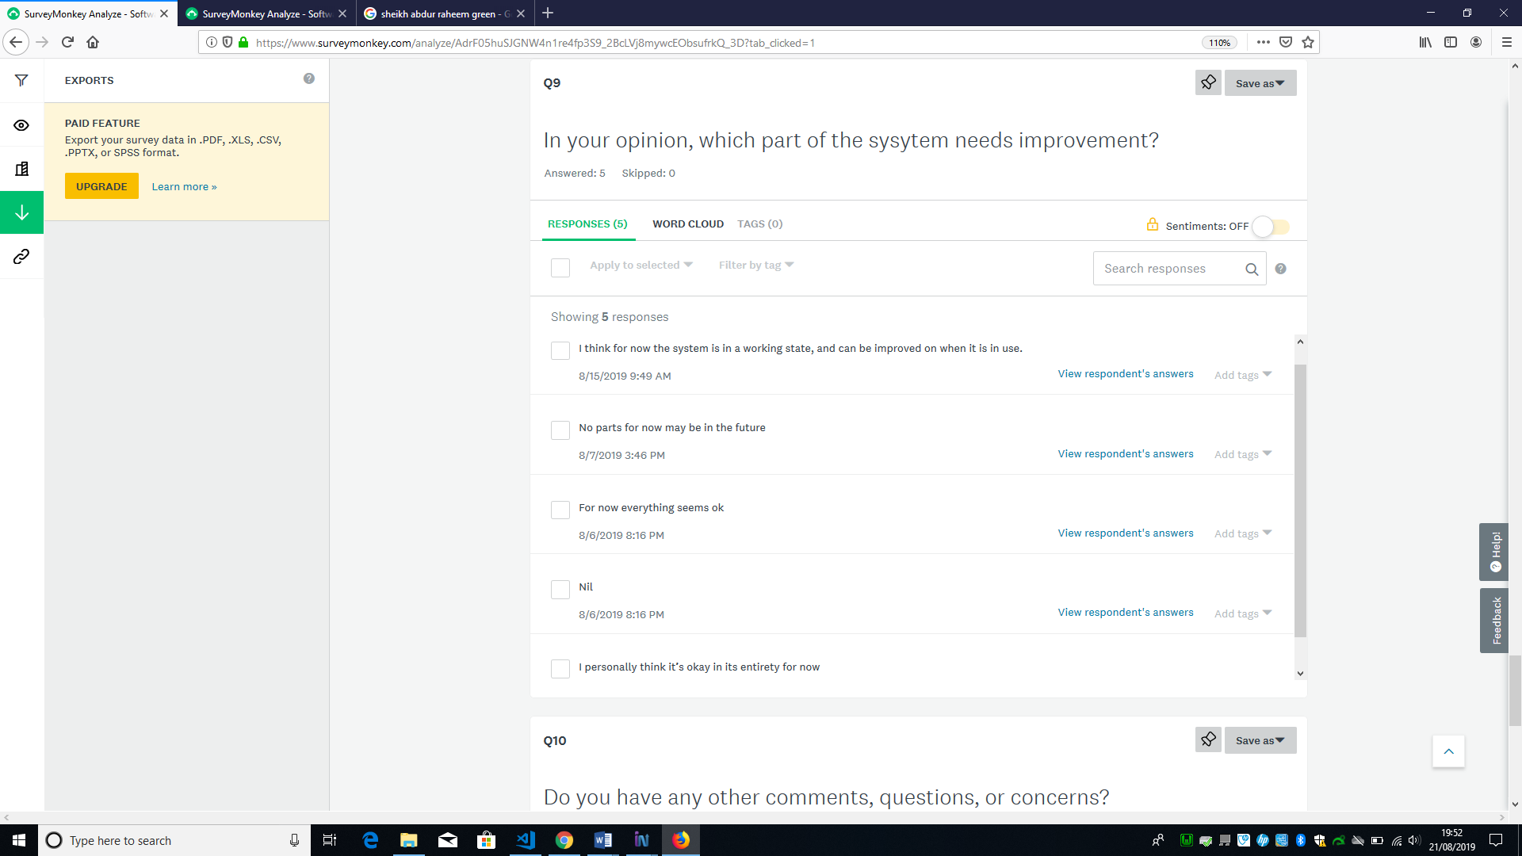

Q10. Do you have any other comments, questions, or concerns? 